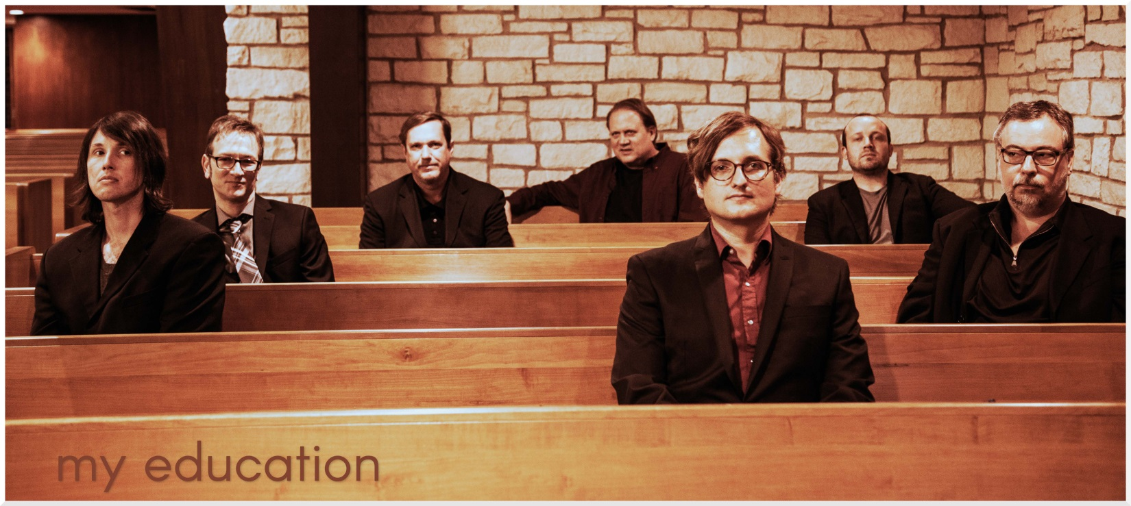

Austin, Texas-based My Education formed in 1999 and has released eight full-length albums. The band’s new album, Schiphol, was produced by **Mike McCarthy** (Spoon, Trail of Dead, Patty Griffin) at Public HiFi studios in Austin.

My Education toured Europe in 2013 and regularly tours the US. They have shared the stage with **A Place to Bury Strangers, Kinski, Bardo Pond, Dalek, The Black Angels, The Sea and Cake, Warpaint, Alexander Hacke/Algis Kizys duo, the Psychedelic Furs, The Soundtrack of Our Lives, This Will Destroy You, Sleepy Sun, White Denim, Radar Bros., Eluvium, Sian Alice Group, Don Caballero, Trans Am** and many others. Additionally, My Education has joined **Maserati** and the **Red Sparowes** on multi-date regional tours.

My Education loves collaboration and specializes in new media crosscurrents. The band’s collaboration with Houston’s **NobleMotion Dance company** premiered with three sold out shows in 2011 at Ballet Austin; a second collaboration in late 2013 sold out two shows at Houston’s Hobby Center. The band has also recently completed the score to a new film by CM Talkington, director of the cult classic “Love and a 45”, entitled “**Mud, Mules and Mountains**”. The new film, which tells the story of the invasion of Italy by the raw recruits of the Texas 36th Infantry Division in 1943, premiered at the Telluride Film Festival in 2015 and is currently working the film festival circuit.

My Education’s previous albums include 5 Popes, Italian, Moody Dipper, and Bad Vibrations. Recordings have been remixed by members of bands Kinski, Pelican, the Red Sparowes and Dalek. A remastered edition of My Education's debut LP 5 Popes was released on Beat Imprint Records in 2013. Reviews included:

*“This Austin sextet expands on the arc-riff grandeur or local travelers Explosions in the Sky with John Cale-like viola and simple, rising melodies that take you way up and out. My surprise find at SXSW this year, My Education is advanced ecstasy."*

**–– David Fricke, Rolling Stone Magazine**

*"The group introduces stately melodies, often topped by violin, and then cycles through them, building variations by small increments from within — an additional cymbal crash here, a tremolo there, some slowly dawning feedback, some thickening keyboard chords — until the music looms as monumental, even overwhelming. Patience becomes a detonator."*

**–– Jon Pareles, New York Times**

*"The instrumental quintet My Education composes wordless songs through vast, gorgeously orchestrated soundscapes. From squealing electric guitar wails to screeching viola yelps, the band's music has all the vocals it needs, drawing its narrative tension from ambient dischord." ––* **Conor McKay, NPR**

*"My Education built their reputation upon their unique approach to composition, their improvisational skill, and their fearless experimental soundscapes… They’ve been touring steadily since 2001, performing for audiences in the U.S. and, for the first time, throughout Europe this past spring."*

**–– Laurie Gallardo, KUTX 98.9**

**Track Listing:** Intro | Open Marriages | Coordinates | Class A | Krampus | This Let's Rock (for Mary) | Grey An | Reekei Plume-Plucked Minnow | Reprise (Coordinates)

Release Date: March 3rd 2017 | Format: CD/LP | Catalog Number: HB002

**RIYL:** Mono, Godspeed You! Black Emperor, Rachel’s, Balmorhea, Explosions in the Sky, DirtyThree

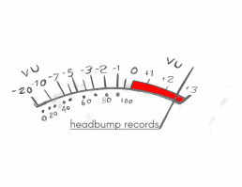

**Artist:** My Education: [band@myeducationmusic.com](mailto:band@myeducationmusic.com)

**Publicity/Management:** Ryan Cano/The Loyalty Firm: [ryan@theloyaltyfirm.com](mailto:ryan@theloyaltyfirm.com)

**Headbump Records:** 8400 Appalachian Dr Austin, TX 78759 USA